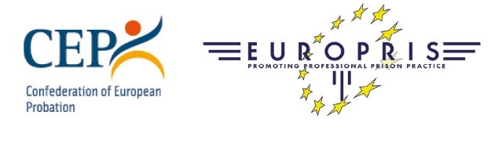

Interagency Cooperation Workshop
Bucharest, Romania
23-24 November 2022

Paper submission form

Name of Speaker
Names(s) of any co-speakers
Organisation/Agency
Country
Email Address
Telephone Number (incl. Country Code)

- Brief Description: This should be a summary explanation of what the presentation is about. Maximum 300 words.

- Title: Please provide the title of your presentation.

- Biography: Enter a brief biography here (100 words). Include a biography for any co-speakers (If applicable). Do not send or include a CV.

This form should be returned no later than 09 September 2022 to gustavtallving@europris.org .
We will inform you by end of September on the outcome of the review of all paper submissions. In the meantime, please do mark the dates in your calendar.

Thank you for your interest and cooperation!

